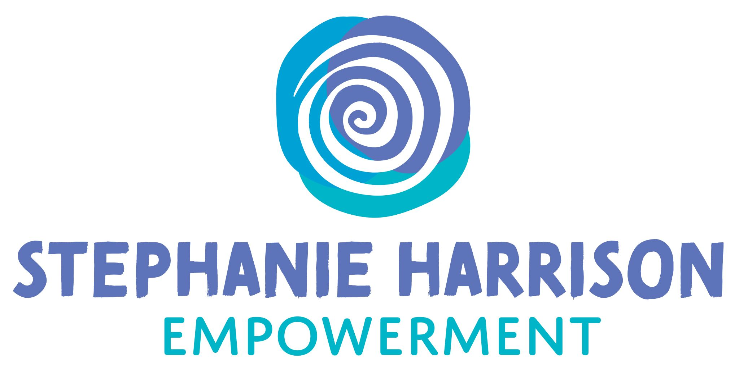

Child’s Name …………………………………………………….

By signing this form I give permission for my child / children to have their photograph on Archie’s Adventures Webpage. I also give permission for my child’s / children’s photograph to be used on Archie’s Adventures Instagram Page, Stephanie Harrison Empowerment Facebook and Instagram pages for promotional purposes regarding Archie’s Adventures book series.

……………………………….. ……………………………

Signed Relationship to child

…………………………

Date

Please indicate the name to be used to refer to the child (this does not need to be the child’s real name)

……………………………..

…………………………….